NAF Deploy Server 54:
cd /home/script
./naf_qc_build.sh
cd /home/script/naf/dist
ls
rm -rf /opt/tomcat/webapps/naf/*
cp -rf naf.war /opt/tomcat/webapps/naf/
cd /opt/tomcat/webapps/naf/
jar -xvf naf.war
rm naf.war

Restart server

NAF Deploy Server 81:

- Take checkout from Head→ NAF
- 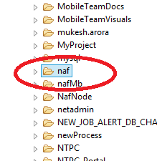

- Do the below changes on /opt/tomcat/webapps/naf/WEB-INF/mongo-config.xml
<constructor-arg value="192.168.206.82:27017"/>
<constructor-arg value="192.168.206.82:27017"/>

- Create build from cmd
- Open putty and go to the below path on 81 server,
User: tjadmin/tjadmin123
/opt/tomcat/webapps/naf
- Remove old naf build
Cd /opt/tomcat/webapps/naf
rm –rf *
- Copy the recently created naf.war from system to the following path,
/opt/tomcat/webapps/naf
- Extract the war file,
Jar –xvf naf.war
- Remove the war file → rm naf.war
- Restart tomcat

After server UP check with the below URL,
http://115.112.206.81/naf/

OP: This is my JSP page.

